Park View Project Updates Sep’t 2021 EDITION 1

In this issue:
Emerging from the pandemic
Volunteer recruitment
Drop-in update
Future goals: Digital First Aid / Reboot scheme.
Donations
New developments

Photo Caption

Welcome to our first post lock-down edition in 2021
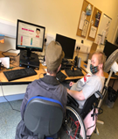
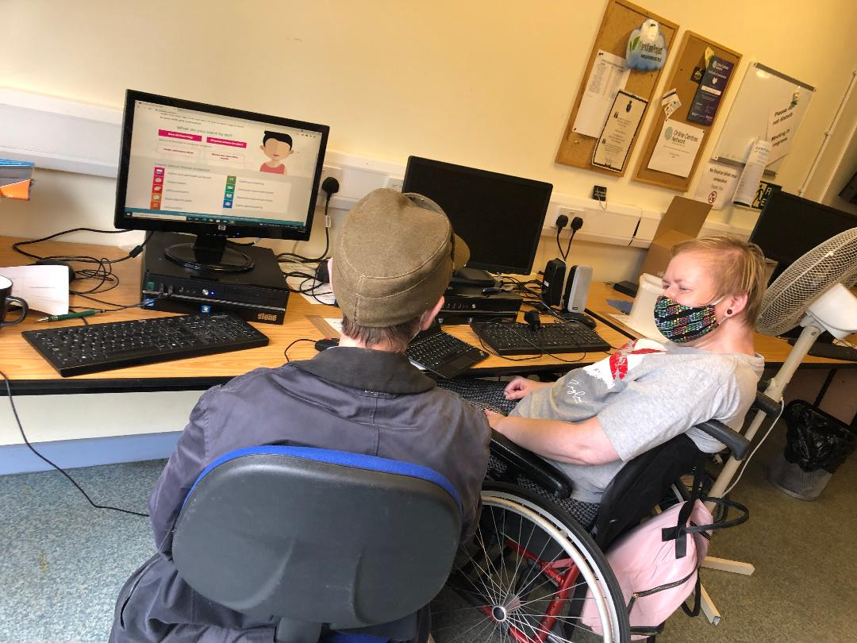
During the lock-down we were still able to provide some support to our customers. Unfortunately, this was limited because many of those we serve have few, if any, digital skills to perform video calling. To help things along we installed a piece of software called Team Viewer. TeamViewer provides remote connectivity using a cloud-based platform that enables secure remote access to any device, across platforms, from anywhere, anytime. TeamViewer connects computers, smartphones, servers, IoT (Internet of Things); this meant we could easily help someone to set up their device. The only thing they needed was to turn on the device and at least have access to an email address. For many it is a start, and for some this was a useful way of working during the interim lock-down period. Secondly, we continue to use all non-digital channels such as telephone and printed material where necessary to ensure that nobody misses out on information and, critically, feel less alone.

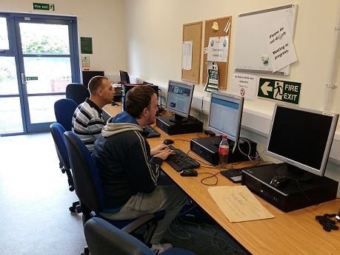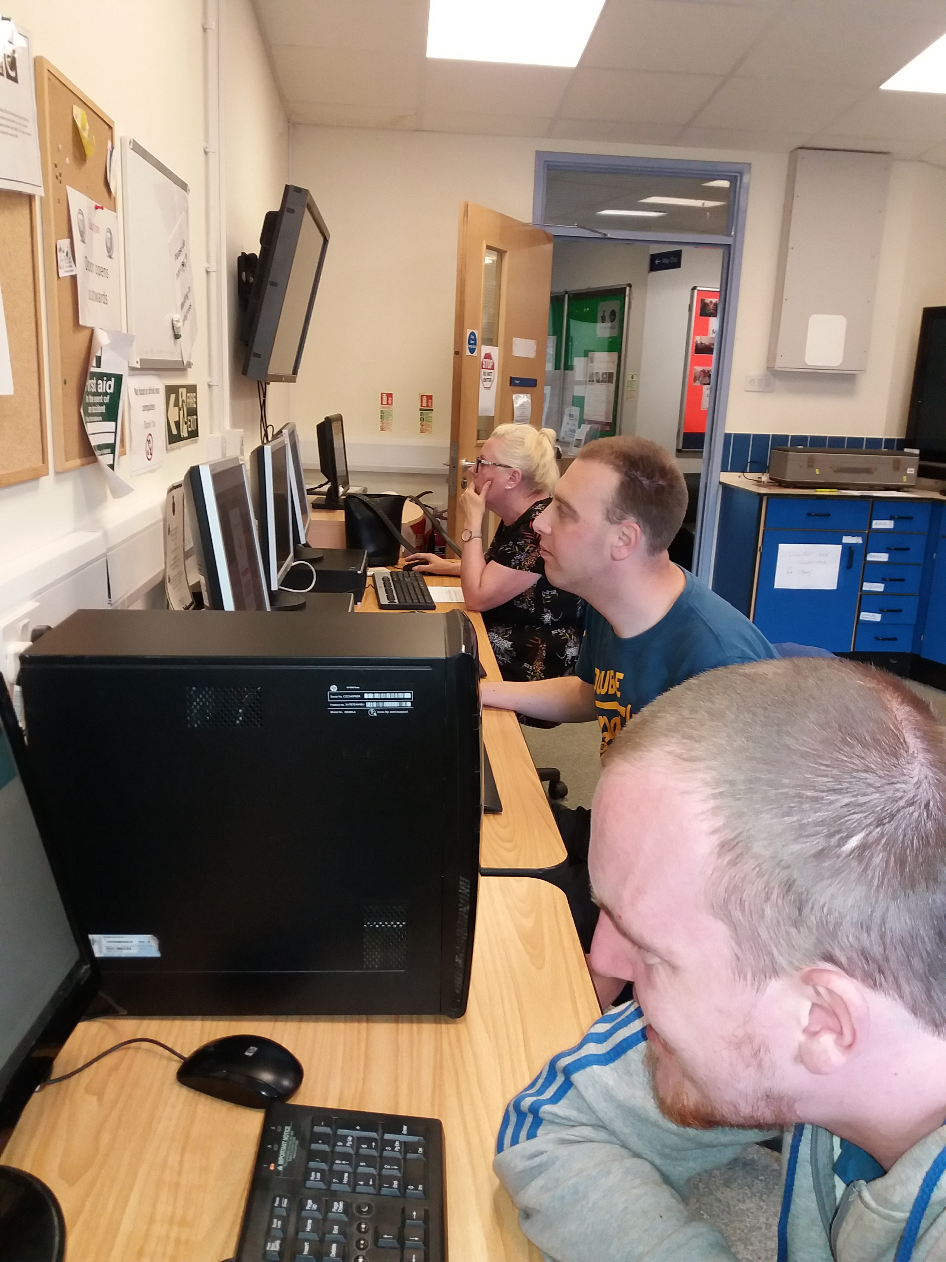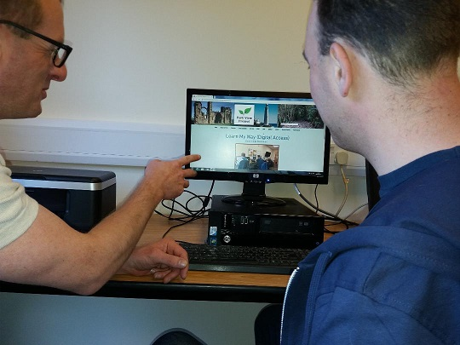
Volunteer recruitment:
We are actively seeking volunteers to become Online Chum Mentors. You can find out about this role via our website: https://www.parkviewprojectne.com/volunteer
We are especially interested in residents with skills in website management/design/content relating to Wix web platform and someone with writing skills who can translate ‘how to’ instructions for people with little or no digital skills, i.e., basic use of android/apple, etc., Phones/iPad. If you want to know more, you can contact Bob on 0191 466 1667 or email office@parkviewproject.org.uk Link to volunteer recruitment application and opportunities: Volunteer application form
Revamping of our drop-in service:
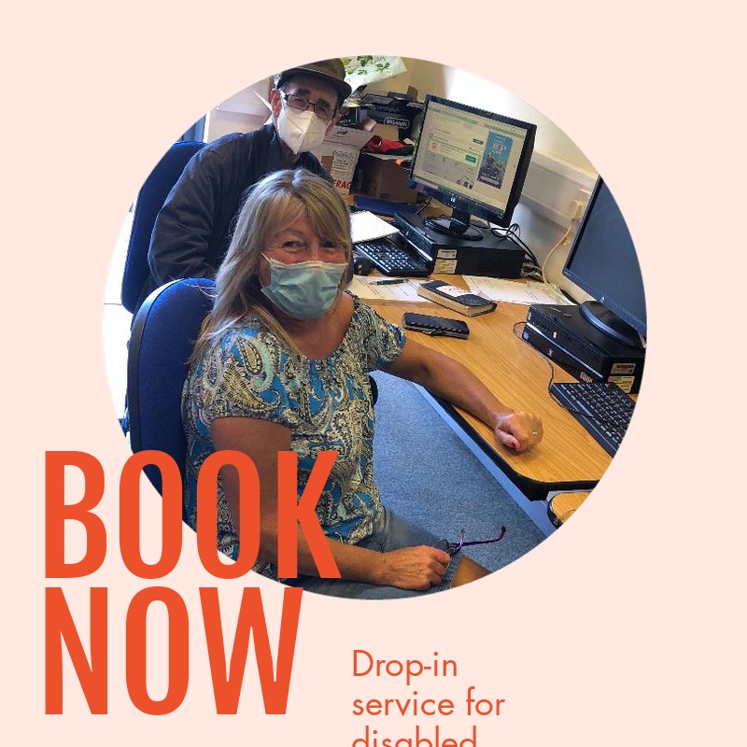
We have taken possession of new mini desktops to compliment already available hardware including a recent edition of a mac desktop, alongside tablets and iPads that can be used for learning purposes. We also have on order new pieces of Assistive Technology such as head pointers, track ball mice and roller balls. These devices will help those with physical disabilities to access online services easier.
Charity registration:
This has been an ongoing piece of work which was temporarily put to one side due to project demand pressures. We are now in a position to move forward on creating charity status, which will help with increasing number of donors we can approach, allow for important software support and greater opportunities for more formal collaboration with other local organisations regarding future projects.
Future goals:
We are researching how to become the first centre to adopt the status of Digital Accessible Hub. Here is the link to the proposals, which are featured on our website Digital First Aid - Future developments Digital First Aid objectives:
- ​To enable people with disabilities, older and those digitally excluded to access assistive technology to get online.
- ‘Digital First Aid’ training delivered by disabled people for disabled people
- Improve health, self-care, and choice for all disenfranchised on the digital periphery.
- North Tyneside community will promote and enable positive health, wellbeing, and independence in North Tyneside through increased access to digital health technology.
Reboot Scheme:
Our role in addressing affordability of digital items and connectivity has led us to evaluate the possibilities of establishing a local Reboot Scheme, which would allow local recycling of digital items. This has a social and economic community benefit because it would raise public awareness of those on the digital periphery, and as a valuable asset in developing a local focus that show-cases community self-help initiatives taking place in North Tyneside: ..\..\OneDrive - North Tyneside Disability Forum\Desktop\Reboot Guide Jan 21.pdf
Use of interactive games as a tool for digital learning:
Alternative learning strategies that make teaching basic digital skills interesting and entertaining will involve for example Train Sim World Two, which involves using online navigating and cognitive skills that help with managing a variety of online interactions. Take a look and see what you think: Train Sim World Two is one example of an online games platform that is both fun and demanding. We are also looking to identify online word games, which amount to more than playing just for fun but can help with literacy, language development as well as creative skills.
Digital Loan Library: We are looking to make good use of items donated to form a loans library. This is early days, but will update on our next newsletter.
Donations 2020/21:
2020 begun with two funding awards with £1,000 from R W Mann Trust and a further £1,000 from Ballinger Trust. We also received funding from The Children’s Fund of £996.00. This will help us reach out to individuals linked to our partner network by providing hands on digital learning with a further £856.00 to Celebrate National Lottery 25 years. We received help from local organisations such as Karbon Homes and Newcastle Round Table who have responded to the national emergency (Covid19) with resources to reach out to those experiencing digital poverty. Good Things Foundation with the help of a donation from Future Now received five Lenovo M7 Mini Tablets providing a lifeline for those with a disability who have no presence online. Further support was made possible from National Community Lottery to cover costs of additional training to volunteer Online Chum Mentors covering six months and most recently a donation from the Catherine Cookson Trust to support Covid19 restrictions during closure of our drop-in services. We have recently received support from Thomas Wall Trust and the Rothley Trust to test early-stage piloting of Assistive Technology interventions that will inform our Digital First Aid future plans.
Access to on-site café facilities (North Tyneside Disability Forum):
Following closure owing to the pandemic access to this facility will be available to volunteers and users of our drop-in services. The café, managed by NTDF, should be opening in stages with only Thursday afternoons so far scheduled. However, Tuesday and Wednesdays should be available to our project over the coming months.
New developments: We have now finalised our Digital Self-Assessment form, which you can now access via this link: Digital Self-Assessment This will help us to understand the current state of access along with details of some of the barriers you or your friends or family may have. So we urge you to spend up to 15 minutes maximum on this form. (All data collected and stored is according to GDPR current UK Government legislation.
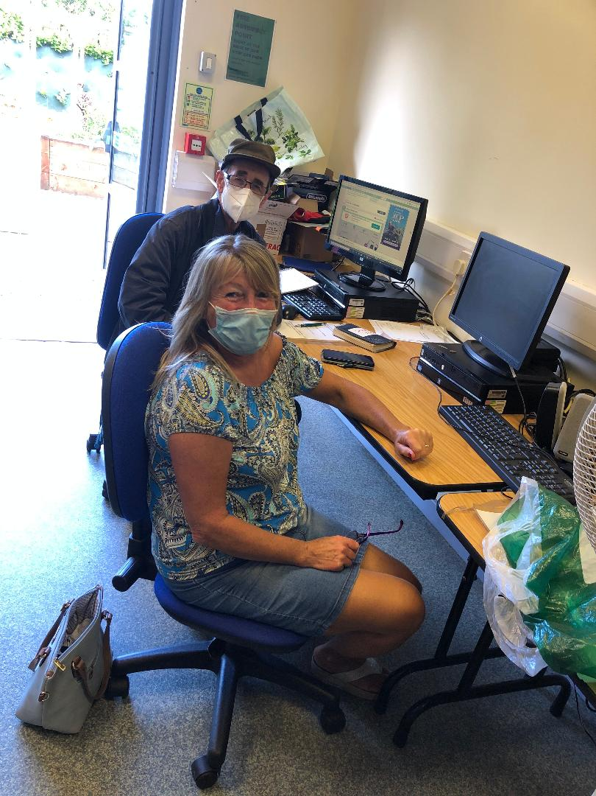
Park View Project: C/O NTDF, Shiremoor Centre, Earsdon Road, Shiremoor, Newcastle Upon Tyne, NE27 0HJ
Website: www.parkviewprojectne.com
office@parkviewproject.org.uk 0191 4661667

